Question 1: What is a conditional statement in programming?
*Problem Statement
A conditional statement allows a program to make decisions and execute different code blocks based on
whether a condition is true or false.
*Algorithm / Steps
1. Evaluate a condition (Boolean expression).
2. If TRUE -> execute one block of code.
3. If FALSE -> skip or execute an alternative block.
*Dry Run
int x = 10;
Condition: x > 5-> 10 > 5 is TRUE-> Execute the if-block
*C++ Code
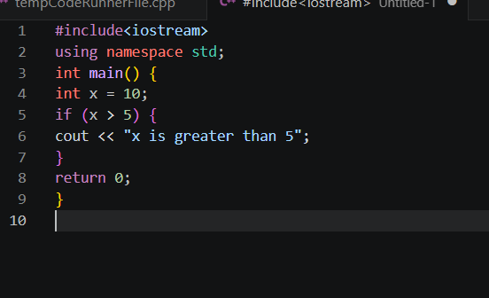
*Output
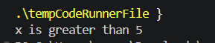
*Explanation of Logic
The if statement checks x > 5. Since 10 > 5 is true, the block executes and prints the message. Conditional
statements give programs the ability to choose different execution paths.
Question 2: What does an if statement do?
*Problem Statement
An if statement evaluates a condition. If the condition is true, it executes the code inside its block;
otherwise, it skips it.
*Algorithm / Steps
1. Write condition inside if( ).
2. Place code to execute inside { }.
3. If condition is true -> code runs.
4. If condition is false -> code is skipped.
*Dry Run
int marks = 60;
if (marks >= 50)-> 60 >= 50 is TRUE -> prints "Pass"
*C++ Code
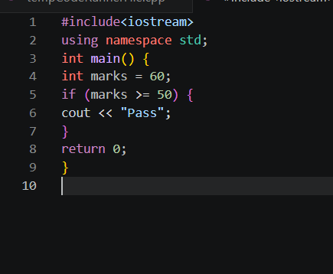
*Output
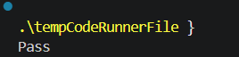
*Explanation of Logic
The if statement checks marks >= 50. Since 60 >= 50 is true, 'Pass' is printed. If marks were 40, nothing
would print because the condition would be false.
Question 3: What is the purpose of an else block?
*Problem Statement
The else block provides an alternative set of instructions to execute when the if condition is false.
*Algorithm / Steps
1. Write the if condition.
2. Add else { } after the if block.
3. If condition TRUE -> if-block runs.
4. If condition FALSE -> else-block runs.
*Dry Run
int marks = 40;
if (marks >= 50) -> FALSE
else -> executes -> prints "Fail"
*C++ Code
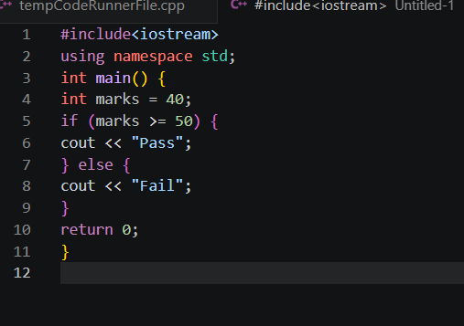
*Output
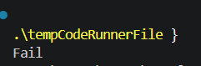
*Explanation of Logic
Since marks = 40 and 40 >= 50 is false, the else block runs and prints 'Fail'. The else ensures the program
always does something useful regardless of the condition outcome.
Question 4: When is an else block executed?
*Problem Statement
The else block is executed only when the corresponding if condition evaluates to false.
*Algorithm / Steps
1. Evaluate the if condition.
2. If TRUE -> if-block executes, else-block is SKIPPED.
3. If FALSE -> if-block is SKIPPED, else-block executes.
*Dry Run
Case 1: x = 3
if (x > 5) -> FALSE -> else runs -> "Not greater"

Case 2: x = 8
if (x > 5) -> TRUE -> if runs -> "Greater"
*C++ Code
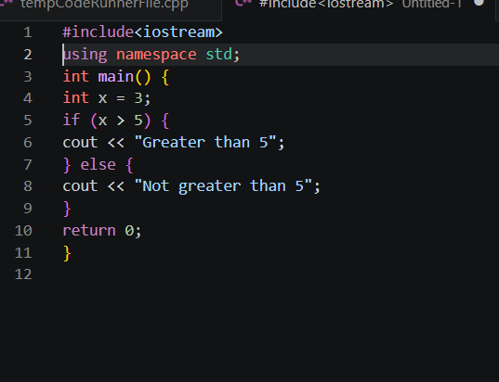
*Output
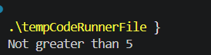
*Explanation of Logic
Exactly one of if or else always executes — never both. When x=3, x>5 is false, so the else block runs.
The two blocks are mutually exclusive.
Question 5: What is a Boolean expression?
*Problem Statement
A Boolean expression is any expression that evaluates to either true (1) or false (0). It is used as the
condition inside if, while, and other control statements.
*Algorithm / Steps
1. A Boolean expression uses relational or logical operators.
2. Examples: x > 5, a == b, marks >= 50, x != 0
3. Result is always true or false.
*Dry Run
int a = 10, b = 5;
a > b -> 10 > 5 -> TRUE (1)
a == b -> 10 == 5 -> FALSE (0)
a != b -> 10 != 5 -> TRUE (1)
*C++ Code
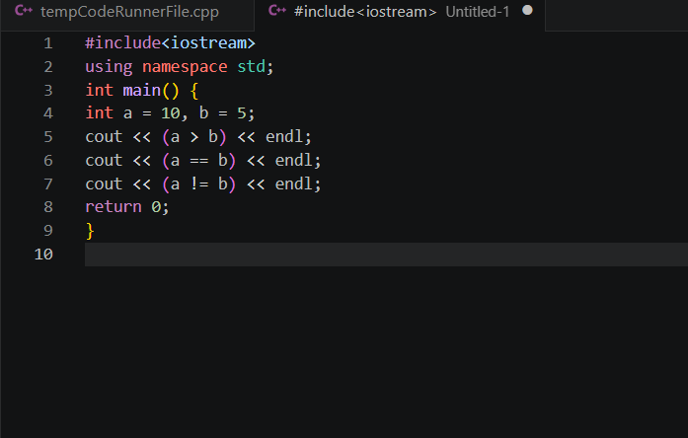
*Output
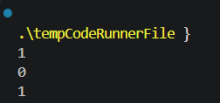
*Explanation of Logic
Boolean expressions are the core of decision-making. They use relational operators (>, <, ==, !=, >=, <=)
and return 1 for true or 0 for false. The if statement needs a Boolean expression to decide which path to
take.
Question 6: Write the syntax of a simple if statement.
*Problem Statement
Write and explain the standard syntax (template) of a simple if statement in C++.
*Algorithm / Steps
Syntax:
if (condition) {
// code to execute if condition is true
}
Steps:
1. 'if' keyword followed by condition in parentheses.
2. Body enclosed in curly braces {}.
3. Body executes only when condition is true.
*Dry Run
if (x > 0) {
cout << "Positive";
}
x = 5: 5 > 0 -> TRUE -> prints "Positive"
x = -2: -2 > 0 -> FALSE -> nothing printed
*C++ Code
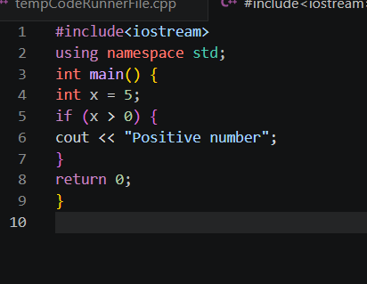
*Output
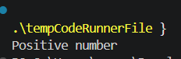
*Explanation of Logic
The if keyword, followed by a condition in (), followed by a body in {} is the basic syntax. The body runs
only when the condition is true. Omitting {} is allowed for single statements but is bad practice.
Question 7: What operator is commonly used to test equality?
*Problem Statement
Identify the operator used in C++ to compare two values for equality in a condition.
*Algorithm / Steps
1. == (double equals) is the equality operator.
2. It compares two values and returns true/false.
3. Do NOT confuse with = (assignment).
*Dry Run
int a = 5;
a == 5 -> TRUE (1)
a == 3 -> FALSE (0)
a = 3 -> assigns 3 to a (not a comparison!)
*C++ Code
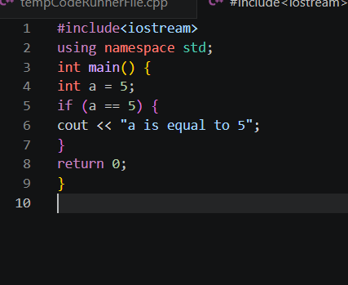
*Output
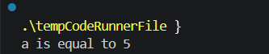
*Explanation of Logic
== compares two values and returns true if they are equal. Using = inside an if condition accidentally
assigns a value instead of comparing — a very common bug. Always use == for comparison.
Question 8: What does the modulus (%) operator return?
*Problem Statement
Explain the modulus operator and what value it produces.
*Algorithm / Steps
1. % returns the remainder after integer division.
2. Formula: a % b = remainder when a is divided by b.
3. Commonly used to check even/odd or divisibility.
*Dry Run
10 % 3 -> 10/3 = 3 remainder 1 -> result: 1
8 % 2 -> 8/2 = 4 remainder 0 -> result: 0
7 % 5 -> 7/5 = 1 remainder 2 -> result: 2
*C++ Code
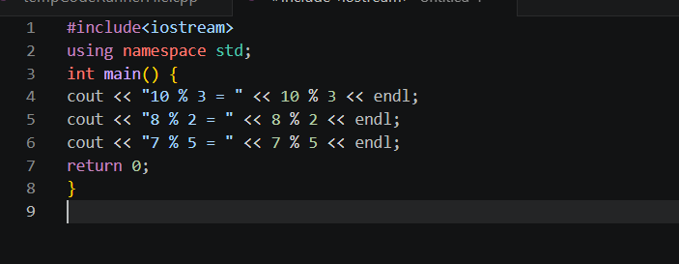
*Output
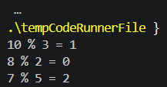
*Explanation of Logic
The modulus operator % gives the leftover after division. If a%b == 0, then a is perfectly divisible by b. This
is the standard tool for checking even/odd (n%2==0 means even) and leap years.
Question 9: How can you check if a number is even?
*Problem Statement
Write a C++ program that checks whether a given integer is even using the modulus operator.
*Algorithm / Steps
1. Read integer n.
2. Compute n % 2.
3. If n % 2 == 0 -> number is even.
4. Else -> number is odd.
*Dry Run
n = 8
8 % 2 = 0 -> condition TRUE -> "Even"
n = 7
7 % 2 = 1 -> condition FALSE -> "Odd"
*C++ Code
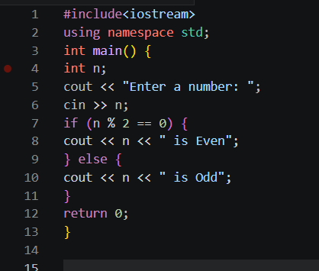
*Output
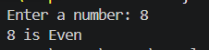
*Explanation of Logic
A number is even if it leaves no remainder when divided by 2. n % 2 == 0 is the standard condition. If the
remainder is 1, the number is odd. The modulus operator makes this check simple and efficient.
Question 10: How can you check if a number is odd?
*Problem Statement
Write a C++ program that determines whether an integer is odd.
*Algorithm / Steps
1. Read integer n.
2. Compute n % 2.
3. If n % 2 != 0 (remainder is 1) -> number is odd.
4. Else -> even.
*Dry Run
n = 7
7 % 2 = 1 -> 1 != 0 -> TRUE -> "Odd"

n = 4
4 % 2 = 0 -> 0 != 0 -> FALSE -> "Even"
*C++ Code
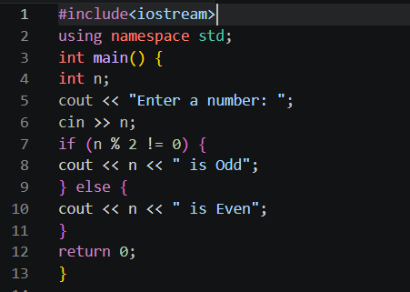
*Output
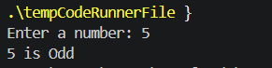
*Explanation of Logic
A number is odd when dividing by 2 leaves a remainder of 1. n % 2 != 0 captures this. Both even and odd
checks use modulus — only the condition differs (== 0 for even, != 0 for odd).
Question 11: What is the purpose of else-if?
*Problem Statement
Explain the else-if construct and when it is used instead of multiple separate if statements.
*Algorithm / Steps
1. else-if creates a chain of conditions.
2. Checked in order: first true one executes.
3. Only one block in the chain runs.
4. Optional final else handles no-match case.
*Dry Run
marks = 75
if (marks >= 90) -> FALSE
else if (marks >= 75) -> TRUE -> prints "B Grade"
(remaining else-ifs not checked)
*C++ Code
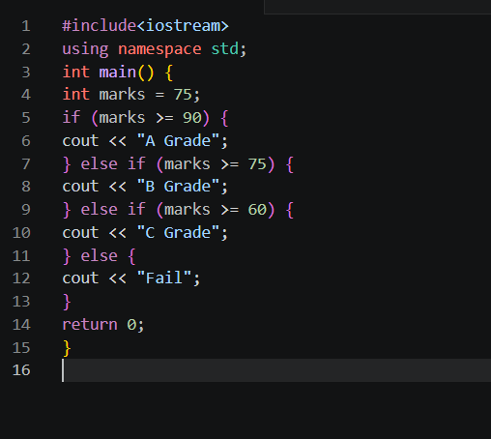
*Output
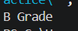
*Explanation of Logic
else-if allows testing multiple mutually exclusive conditions in sequence. As soon as one is true, its block
runs and the rest are skipped. This is more efficient than multiple independent if statements when only one
outcome is expected.
Question 12: What is a nested if statement?
*Problem Statement
Define nested if and demonstrate a situation where one if statement is placed inside another.
*Algorithm / Steps
1. An if (or else) block contains another if inside it.
2. Inner if is evaluated only when outer if is true.
3. Used to check multiple related conditions.
*Dry Run
num = 10
Outer: num > 0 -> TRUE -> enter outer if
Inner: num % 2 == 0 -> TRUE -> "Positive Even"
*C++ Code
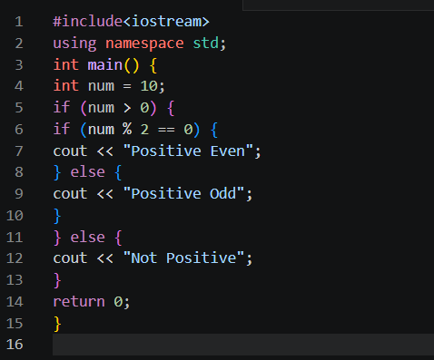
*Output
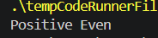
*Explanation of Logic
Nested ifs evaluate a second condition only after the first is confirmed true. This avoids unnecessary
checks. Here, we first confirm the number is positive, then check if it is even.
Question 13: Can an if statement exist without an else?
*Problem Statement
Determine whether an if statement requires a corresponding else block in C++.
*Algorithm / Steps
1. else is optional in C++.
2. If condition is true -> if-block runs.
3. If condition is false -> nothing happens; program continues.
*Dry Run
int x = 3;
if (x > 10) {
cout << "Big"; // x=3: 3>10 FALSE -> skipped
}
cout << "Done"; // always prints
*C++ Code
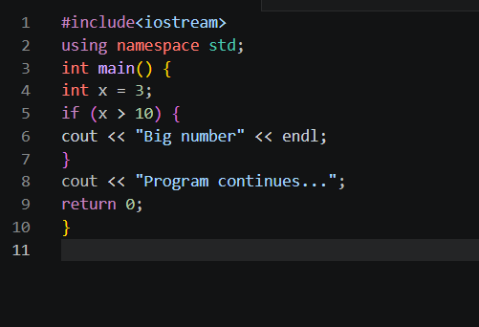
*Output
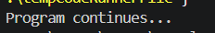
*Explanation of Logic
else is not mandatory. When no else is present and the condition is false, the if-block is skipped silently
and execution continues with the next statement. Use else only when an alternative action is needed.
else?
Question 14: What is the output when a false condition is tested without
*Problem Statement
Predict and explain the output when an if condition is false and there is no else block.
*Algorithm / Steps
1. Evaluate if condition.
2. Condition is FALSE -> if-block is skipped.
3. No else block present -> nothing printed from if.
4. Code after if continues normally.
*Dry Run
int a = 2;
if (a > 5) -> 2 > 5 -> FALSE -> block skipped
cout << "End"; -> always executes
*C++ Code
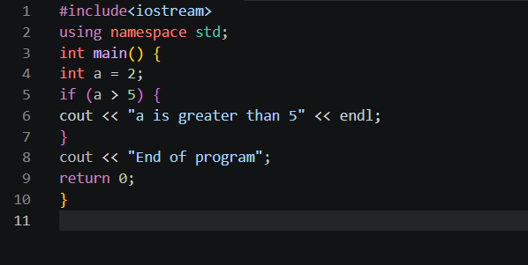
*Output
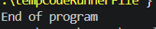
*Explanation of Logic
When the condition is false and no else exists, the if-block is simply skipped. The program produces no
output from the if statement itself and moves on. No error occurs — it is perfectly valid C++.
Question 15: What is the role of braces {} in C/C++ conditionals?
*Problem Statement
Explain the purpose of curly braces {} in if-else and other conditional structures.
*Algorithm / Steps
1. {} define a block (group) of statements.
2. All statements inside {} belong to that if/else.
3. Without {}, only the very next statement is part of if.
4. Using {} is always recommended for clarity.
*Dry Run
Without {}:
if (x > 0)
cout << "Pos"; // part of if
cout << "Always"; // NOT part of if — always runs!

With {}:
if (x > 0) {
cout << "Pos";
cout << "Always"; // both inside if block
}
*C++ Code
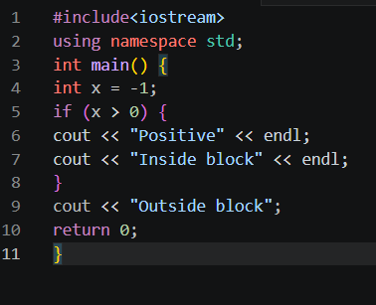

*Output
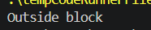
*Explanation of Logic
Curly braces group multiple statements into one block. Without them, only the first statement after if is
conditional; the rest always execute. Using {} prevents subtle bugs and makes code readable.
Question 16: What does > mean?
*Problem Statement
Explain the greater-than relational operator > and demonstrate its use.
*Algorithm / Steps
1. > checks if the left operand is strictly greater than the right.
2. Returns true (1) if left > right.
3. Returns false (0) otherwise.
*Dry Run
5 > 3 -> TRUE (1)
3 > 5 -> FALSE (0)
5 > 5 -> FALSE (0) [not strictly greater]
*C++ Code
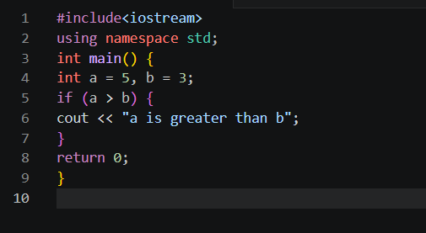
*Output
*Explanation of Logic
The > operator returns true only when the left value is strictly larger than the right. It does not include
equality. Used in comparisons to find maximum values and check thresholds.
Question 17: What does < mean?
*Problem Statement
Explain the less-than relational operator < and demonstrate its use.
*Algorithm / Stepsqy
1. < checks if the left operand is strictly less than the right.
2. Returns true (1) if left < right.
3. Returns false (0) otherwise.
*Dry Run
3 < 5 -> TRUE (1)
5 < 3 -> FALSE (0)
5 < 5 -> FALSE (0) [not strictly less]
*C++ Code
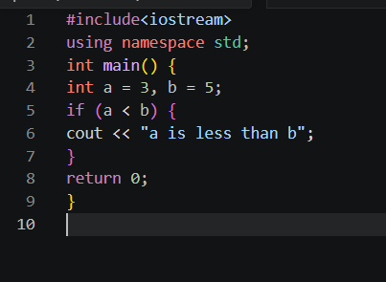
*Output
*Explanation of Logic
The < operator returns true when the left value is strictly smaller than the right. Commonly used to check
minimum values, loop boundaries, and ranking conditions.
Question 18: What does >= mean?
*Problem Statement
Explain the greater-than-or-equal-to operator >= and show its use.
*Algorithm / Steps
1. >= returns true if left operand is GREATER THAN or EQUAL TO right.
2. It includes the equality case unlike >.
3. True when left > right OR left == right.
*Dry Run
5 >= 5 -> TRUE (1) [equal]
6 >= 5 -> TRUE (1) [greater]
4 >= 5 -> FALSE (0) [less]
*C++ Code
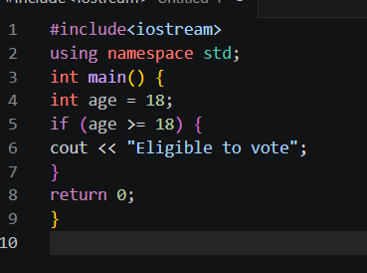
*Output
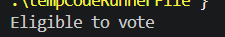
*Explanation of Logic
>= is used when the boundary value itself is also acceptable. For voting eligibility, age must be at least 18,
so >= 18 is correct (includes 18 itself). Using > 18 would wrongly exclude 18-year-olds.
Question 19: What does <= mean?
*Problem Statement
Explain the less-than-or-equal-to operator <= and demonstrate its use.
*Algorithm / Steps
1. <= returns true if left is LESS THAN or EQUAL TO right.
2. Includes the equality case.
3. True when left < right OR left == right.
*Dry Run
3 <= 5 -> TRUE (1) [less]
5 <= 5 -> TRUE (1) [equal]
6 <= 5 -> FALSE (0) [greater]
*C++ Code
#include<iostream>
using namespace std;
int main() {
int speed = 60;
if (speed <= 80) {
cout << "Speed is within limit";
}
return 0;
}
*Output
Speed is within limit
*Explanation of Logic
<= is used when the maximum allowed value is inclusive. Here speed limit is 80, and 60 <= 80 is true. It
covers all values up to and including the boundary.
Question 20: What does != mean?
*Problem Statement
Explain the not-equal-to operator != and demonstrate its use.
*Algorithm / Steps
1. != returns true if two values are NOT equal.
2. Returns false if they are equal.
3. Opposite of the == operator.
*Dry Run
5 != 3 -> TRUE (1) [different values]
5 != 5 -> FALSE (0) [same value]
*C++ Code
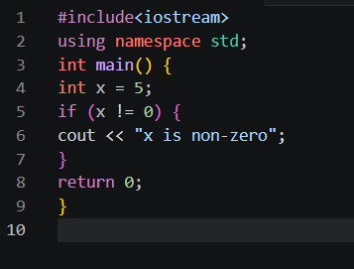
*Output
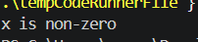
*Explanation of Logic
!= checks inequality. It is the logical complement of ==. Commonly used to check for sentinel/special
values (e.g., check if input is not zero before dividing, or if a user did not quit).
Question 21: What is a switch statement?
*Problem Statement
Define the switch statement and explain when it is preferred over if-else.
*Algorithm / Steps
1. switch evaluates ONE expression (usually int or char).
2. Compares result against multiple case labels.
3. Matching case executes its block.
4. break exits the switch.
5. default handles unmatched values.
*Dry Run
int day = 2;
switch(day):
case 1 -> no match
case 2 -> MATCH -> prints "Tuesday"
break -> exits switch
*C++ Code
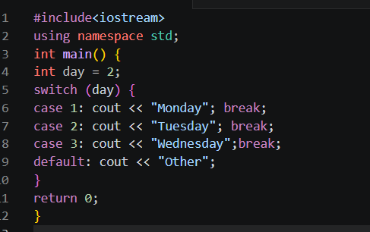
*Output
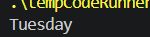
*Explanation of Logic
switch is cleaner than a long if-else-if chain when testing one variable against several constant values. It
jumps directly to the matching case, making code readable and slightly faster for many comparisons.
Question 22: What is a case label in a switch statement?
*Problem Statement
Define and explain the role of a case label inside a switch block.
*Algorithm / Steps
1. case label specifies a constant value to match.
2. Syntax: case value:
3. If switch expression equals the value, execution jumps here.
4. Statements after the label run until break or end of switch.
*Dry Run
switch(x):
case 1: -> checks if x == 1
case 2: -> checks if x == 2
...
x = 2 -> jumps to case 2 label
*C++ Code
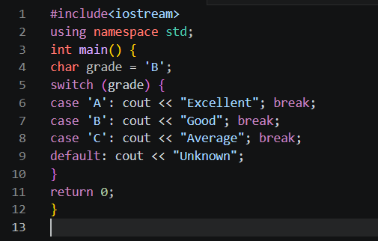
*Output
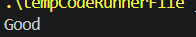
*Explanation of Logic
Each case label is an entry point in the switch block corresponding to a specific constant value. When the
switch expression matches a case, execution starts from that label. Without break, it falls through to the
next case.
Question 23: Why is break used in switch?
*Problem Statement
Explain the purpose of the break statement inside a switch block.
*Algorithm / Steps
1. break exits the switch block immediately.
2. Without break, execution 'falls through' to the next case.
3. break ensures only the matched case executes.
*Dry Run
switch(x), x=1:
case 1: prints "One" -> break -> exits switch
case 2: skipped
case 3: skipped
*C++ Code
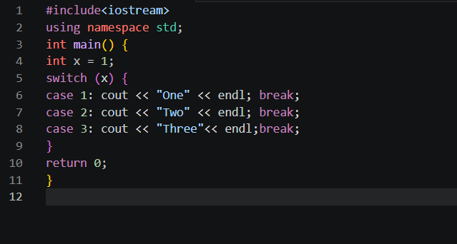
*Output
*Explanation of Logic
Without break, after a case executes, the program continues running into the next case automatically
(fall-through). break terminates the switch and prevents unintended execution of other cases.
Question 24: What happens if break is omitted in switch?
*Problem Statement
Demonstrate the fall-through behavior that occurs when break is missing from a switch case.
*Algorithm / Steps
1. Without break, after matching case executes,
2. Execution continues into the NEXT case(s).
3. This is called fall-through.
4. All subsequent cases run until a break or end of switch.
*Dry Run
x = 1, no breaks:
case 1: prints "One" -> no break -> falls through
case 2: prints "Two" -> no break -> falls through
case 3: prints "Three" -> no break -> falls through
default: prints "Default"
*C++ Code
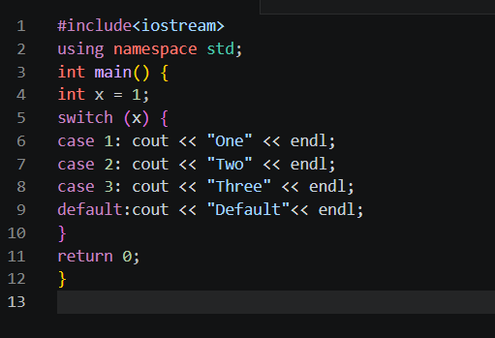
*Output
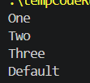
*Explanation of Logic
Fall-through is usually an unintended bug but can sometimes be used deliberately (e.g., multiple cases
sharing the same code). Always add break after each case unless fall-through is specifically intended.
Question 25: What is the default case in switch?
*Problem Statement
Explain the purpose and behavior of the default case in a switch statement.
*Algorithm / Steps
1. default acts as a catch-all when no case matches.
2. It is optional but recommended.
3. Placed at the end (or anywhere, but end is conventional).
4. Executes when switch expression matches no case label.
*Dry Run
x = 9
switch(x):
case 1 -> no match
case 2 -> no match
default-> EXECUTES -> "Unknown"
*C++ Code
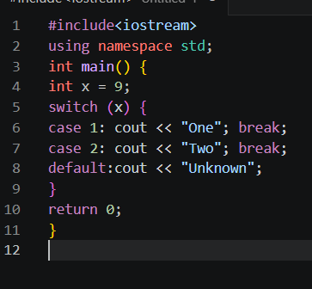
*Output
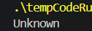
*Explanation of Logic
default provides a safety net for unexpected values. Without it, a switch with no matching case does
nothing. Including default makes programs robust and helps with error handling.
Question 26: Can switch compare strings in C++?
*Problem Statement
Determine whether the switch statement in C++ can be used with string values.
*Algorithm / Steps
1. switch only works with INTEGER types (int, char, enum).
2. Strings CANNOT be used directly in switch.
3. Use if-else-if chain for string comparisons.
4. Alternatively, map strings to integers.
*Dry Run
switch("hello") -> COMPILE ERROR in C++
Use if-else:
if (str == "hello") -> works correctly
*C++ Code
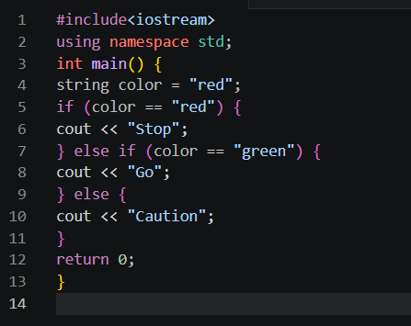
*Output
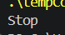
*Explanation of Logic
C++ switch only accepts integral types (int, char, enum). Strings are objects and cannot be used as switch
expressions. Use if-else-if for string comparisons. This is a key limitation compared to some other
languages.
Question 27: Which is better for many constant choices: if-else or switch?
*Problem Statement
Compare if-else and switch and recommend which is more suitable for handling many fixed constant
values.
*Algorithm / Steps
if-else: tests any condition (ranges, strings, complex expressions)
switch: tests ONE variable against CONSTANT values
For many constant choices -> switch is preferred because:- Cleaner and more readable- Slightly faster (uses jump table internally)
*Dry Run
Grade checking with 5 grades:
if-else: 5 separate condition checks
switch: jumps directly to matching case -> faster
*C++ Code
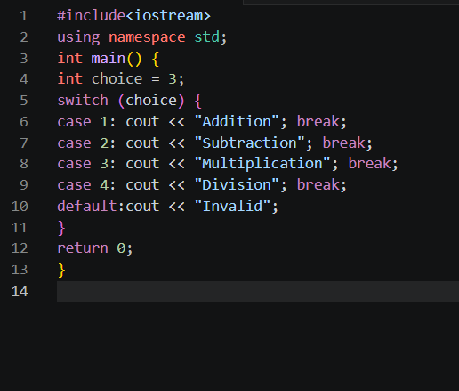
*Output
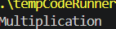
*Explanation of Logic
switch is cleaner for menu-driven programs and when comparing one variable to many constants. if-else is
more flexible (handles ranges, strings, compound conditions). Use switch for constant checks, if-else for
complex logic.
Question 28: How do you test whether a value is positive?
*Problem Statement
Write a C++ program to check if a number entered by the user is positive.
*Algorithm / Steps
1. Read integer n.
2. If n > 0 -> positive.
3. Else -> not positive.
*Dry Run
n = 7
7 > 0 -> TRUE -> "Positive"

n = -3-3 > 0 -> FALSE -> "Not Positive"
*C++ Code
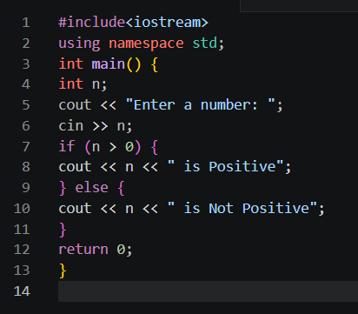
*Output
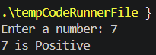
*Explanation of Logic
A number is positive if it is strictly greater than zero. The condition n > 0 captures this. Zero itself is neither
positive nor negative, so > 0 (not >= 0) is the correct check.
Question 29: How do you test whether a value is negative?
*Problem Statement
Write a C++ program to check if a number is negative.
*Algorithm / Steps
1. Read integer n.
2. If n < 0 -> negative.
3. Else -> not negative.
*Dry Run
n = -5-5 < 0 -> TRUE -> "Negative"

n = 4
4 < 0 -> FALSE -> "Not Negative"
*C++ Code
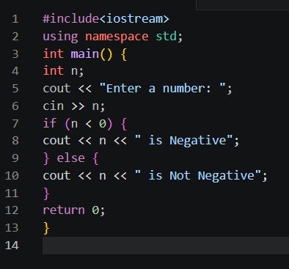
*Output
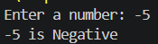
*Explanation of Logic
A number is negative if it is strictly less than zero. The condition n < 0 tests this. Zero is not negative, so <
0 (not <= 0) is the correct operator to use.
Question 30: How do you test whether a value is zero?
*Problem Statement
Write a C++ program that checks if a given number is equal to zero.
*Algorithm / Steps
1. Read integer n.
2. If n == 0 -> zero.
3. Else -> non-zero.
*Dry Run
n = 0
0 == 0 -> TRUE -> "Zero"

n = 5
5 == 0 -> FALSE -> "Non-Zero"
*C++ Code
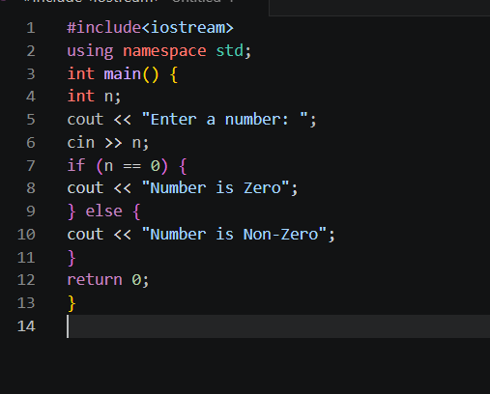
*Output
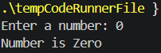
*Explanation of Logic
The equality operator == checks if a value is exactly zero. This check is important in programs that involve
division (to avoid divide-by-zero errors) and in loop termination conditions.
Question 31: Write a condition to check if age is at least 18.
*Problem Statement
Write the correct Boolean condition to verify that a person's age qualifies them as an adult (18 or above).
*Algorithm / Steps
1. 'At least 18' means 18 or older.
2. Condition: age >= 18
3. >= includes both exactly 18 and any higher age.
*Dry Run
age = 18 -> 18 >= 18 -> TRUE -> "Adult"
age = 20 -> 20 >= 18 -> TRUE -> "Adult"
age = 16 -> 16 >= 18 -> FALSE -> "Minor"
*C++ Code
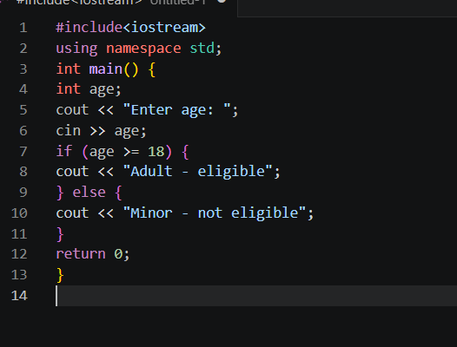
*Output
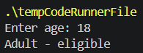
*Explanation of Logic
'At least 18' translates to >= 18 in code, which includes the value 18 itself. Using > 18 would incorrectly
exclude 18-year-olds. Choosing the right operator is critical for correct boundary handling.
Question 32: Write a condition to check if marks are above 50.
*Problem Statement
Write the correct Boolean condition to check whether a student's marks exceed 50.
*Algorithm / Steps
1. 'Above 50' means strictly greater than 50.
2. Condition: marks > 50
3. > 50 does NOT include 50 itself.
*Dry Run
marks = 75 -> 75 > 50 -> TRUE -> "Pass"
marks = 50 -> 50 > 50 -> FALSE -> "Fail"
marks = 40 -> 40 > 50 -> FALSE -> "Fail"
*C++ Code
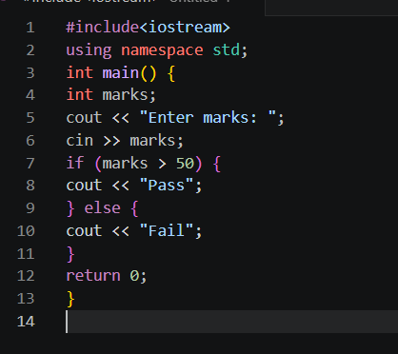
*Output
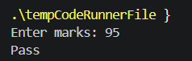
*Explanation of Logic
'Above 50' means strictly greater, so > 50 is correct. If the rule were 'at least 50' (pass at 50 too), we would
use >= 50. Reading the problem carefully to choose > vs >= is essential.
Question 33: What is decision making in programming?
*Problem Statement
Define decision making in the context of programming and explain its importance.
*Algorithm / Steps
1. Decision making = choosing different actions based on conditions.
2. Implemented using: if, if-else, else-if, switch.
3. Allows programs to respond differently to different inputs.
4. Makes programs intelligent and dynamic.
*Dry Run
Without decision making:
Program always does the same thing.
With decision making:
Input 90 -> "Grade A"
Input 75 -> "Grade B"
Input 50 -> "Grade C"
*C++ Code
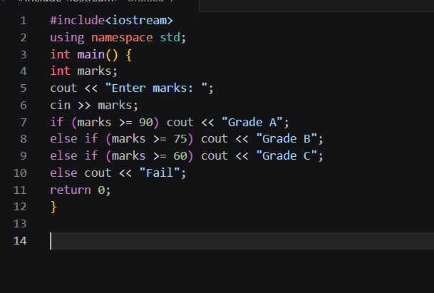
*Output
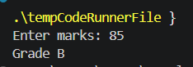
*Explanation of Logic
Decision making is the ability of a program to evaluate conditions and choose different execution paths.
Without it, every run of a program would produce the same output regardless of input, making programs
useless for real problems.
Question 34: Can nested if statements have multiple levels?
*Problem Statement
Demonstrate that nested if statements can be placed inside each other to multiple levels of depth.
*Algorithm / Steps
1. An if block can contain another if (level 2).
2. That inner if can contain yet another if (level 3).
3. In theory, unlimited nesting is possible.
4. In practice, keep nesting shallow for readability.
*Dry Run
x=10, y=5, z=2
Level 1: x > 0 -> TRUE
Level 2: y > 0 -> TRUE
Level 3: z > 0 -> TRUE -> "All positive"
*C++ Code
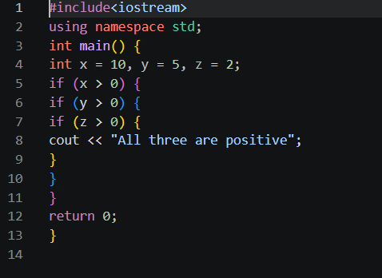
*Output
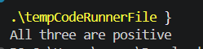
*Explanation of Logic
Nested ifs can go as deep as needed, but deep nesting hurts readability. Often, multiple levels of nested
ifs can be rewritten using logical && to combine conditions into a single if statement.
Question 35: What is logical AND (&&)?
*Problem Statement
Explain the && operator, its truth table, and demonstrate its use in a conditional statement.
*Algorithm / Steps
1. && returns TRUE only if BOTH conditions are true.
2. If either is false -> result is false.
3. Short-circuit: if first is false, second is not checked.
*Dry Run
Truth Table:
T && T = T
T && F = F
F && T = F
F && F = F

a=10, b=5:
(a>0) && (b>0) -> T && T -> TRUE
*C++ Code
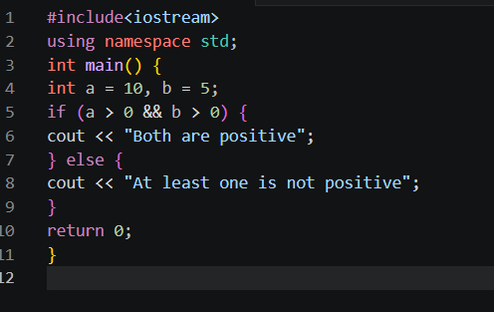
*Output
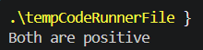
*Explanation of Logic
&& requires ALL conditions to be true. It is used when multiple conditions must all hold simultaneously.
Short-circuit evaluation means if the first condition is false, the second is never evaluated — saving
processing time.
Question 36: What is logical OR (||)?
*Problem Statement
Explain the || operator, its truth table, and demonstrate its use.
*Algorithm / Steps
1. || returns TRUE if AT LEAST ONE condition is true.
2. Returns false only when BOTH are false.
3. Short-circuit: if first is true, second is not checked.
*Dry Run
Truth Table:
T || T = T
T || F = T
F || T = T
F || F = F

a=-5, b=10:
(a>0) || (b>0) -> F || T -> TRUE
*C++ Code
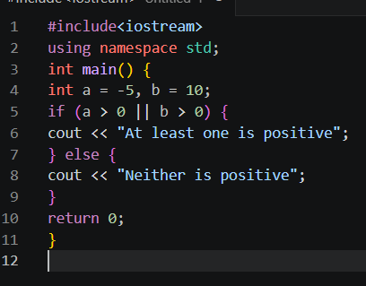
*Output
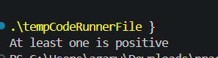
*Explanation of Logic
|| returns true when any one condition is sufficient. It is used when alternatives are acceptable.
Short-circuit evaluation skips the second check when the first is already true, improving efficiency.
Question 37: What is logical NOT (!)?
*Problem Statement
Explain the ! operator and demonstrate how it negates a Boolean condition.
*Algorithm / Steps
1. ! is a unary operator (works on one operand).
2. Negates the Boolean value: !true = false, !false = true.
3. Used to reverse a condition.
*Dry Run
bool flag = true;
!flag = false

int x = 5;
!(x > 10) -> !(false) -> true
!(x > 0) -> !(true) -> false
*C++ Code
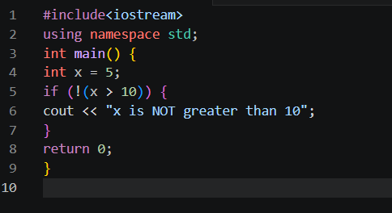
*Output
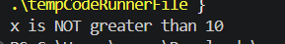
*Explanation of Logic
! flips the boolean result. !(x > 10) is equivalent to (x <= 10). It is useful for writing readable negative
conditions, e.g., if(!isEmpty) reads naturally as 'if not empty'.
Question 38: How do you check if a year is divisible by 4?
*Problem Statement
Write a condition that tests whether a given year is divisible by 4.
*Algorithm / Steps
1. Divisible by 4 means remainder is 0 when divided by 4.
2. Condition: year % 4 == 0
3. If true, year is divisible by 4.
*Dry Run
year = 2024
2024 % 4 = 0 -> TRUE -> divisible by 4

year = 2023
2023 % 4 = 3 -> FALSE -> not divisible
*C++ Code
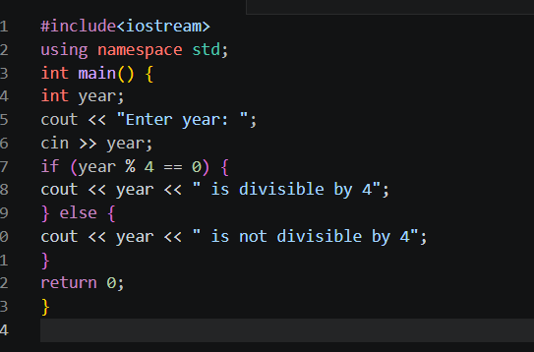
*Output
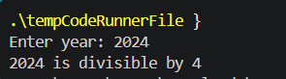
*Explanation of Logic
Divisibility by any number k is checked using the % operator: n % k == 0 means no remainder, so n is
perfectly divisible by k. This is the first step in determining a leap year.
Question 39: What is a leap year?
*Problem Statement
Define a leap year and state the complete set of rules used to determine if a year is a leap year.
*Algorithm / Steps
A year is a leap year if:
Rule 1: Divisible by 4
AND NOT Rule 2: NOT divisible by 100
UNLESS Rule 3: Divisible by 400
Full condition:
(year%4==0 && year%100!=0) || (year%400==0)
*Dry Run
2000: 2000%400==0 -> TRUE -> Leap
1900: 1900%100==0, %400!=0 -> FALSE -> Not Leap
2024: 2024%4==0, %100!=0 -> TRUE -> Leap
2023: 2023%4!=0 -> FALSE -> Not Leap
*C++ Code
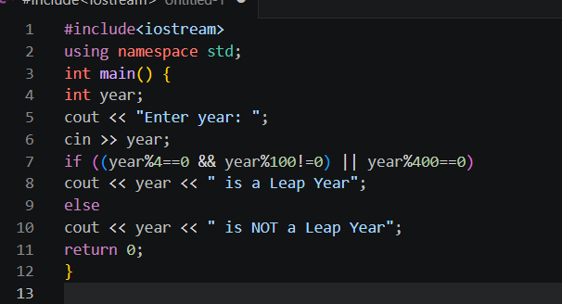
*Output
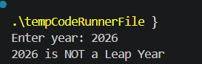
*Explanation of Logic
A leap year has 366 days. The rule exists because Earth takes ~365.25 days to orbit the Sun. The century
exception (divisible by 100 but not 400) fine-tunes the calendar over long periods.
Question 40: What is the first condition for a leap year?
*Problem Statement
State and demonstrate the first (primary) condition used to identify a leap year.
*Algorithm / Steps
First condition: year % 4 == 0
This means the year must be divisible by 4.
Most years satisfying this are leap years,
but century years need the additional 400 check.
*Dry Run
year = 2024
2024 % 4 = 0 -> Satisfies first condition

year = 2023
2023 % 4 = 3 -> Does NOT satisfy first condition
*C++ Code
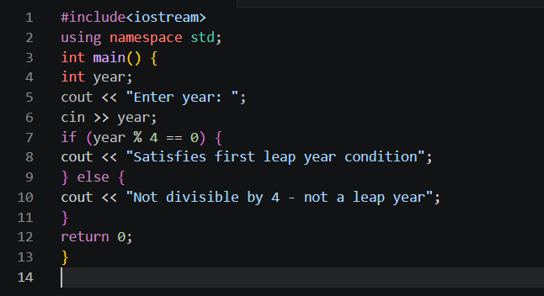
*Output
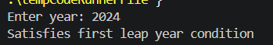
*Explanation of Logic
The first and most basic leap year rule is divisibility by 4. Years like 2024, 2020, 2016 pass this. However,
century years (1900, 1800) also pass but are NOT leap years, which is why further conditions are needed.
Question 41: How do you find the largest of two numbers?
*Problem Statement
Write a C++ program to find and display the larger of two numbers entered by the user.
*Algorithm / Steps
1. Read two numbers a and b.
2. If a > b -> a is largest.
3. Else if b > a -> b is largest.
4. Else -> both are equal.
*Dry Run
a=15, b=10
a > b -> 15 > 10 -> TRUE -> "15 is largest"

a=8, b=12
a > b -> 8 > 12 -> FALSE
b > a -> 12 > 8 -> TRUE -> "12 is largest"
*C++ Code
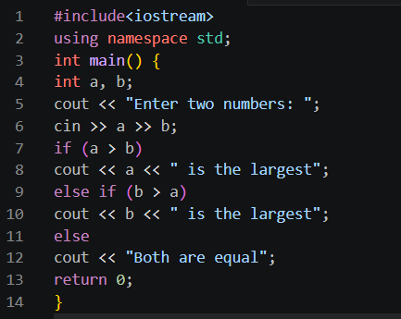
*Output
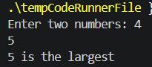
*Explanation of Logic
Comparing two values requires one relational check. If a > b, a wins; if b > a, b wins; if neither, they are
equal. This covers all three possible relationships between two numbers.
Question 42: How do you find the largest of three numbers?
*Problem Statement
Write a C++ program to find the largest among three numbers using conditional statements.
*Algorithm / Steps
1. Read three numbers a, b, c.
2. If a>=b and a>=c -> a is largest.
3. Else if b>=a and b>=c -> b is largest.
4. Else -> c is largest.
*Dry Run
a=10, b=30, c=20
a>=b -> 10>=30 -> FALSE
b>=a -> 30>=10 -> TRUE
b>=c -> 30>=20 -> TRUE -> "30 is largest"
*C++ Code
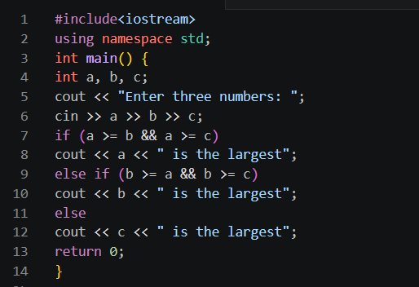
*Output
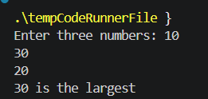
*Explanation of Logic
To find the largest of three, each candidate must be compared against the other two. Using && combines
both comparisons. The number that is greater than or equal to both others is the maximum.
Question 43: What is an if-else-if ladder?
*Problem Statement
Define the if-else-if ladder and explain how it differs from multiple independent if statements.
*Algorithm / Steps
Structure:
if (condition1) -> check first
else if (condition2) -> check only if first false
else if (condition3) -> check only if both above false
else -> default if all false
Only ONE block executes.
*Dry Run
marks=75
if (>=90) -> FALSE
else if (>=75) -> TRUE -> "B Grade" -> STOP
(remaining conditions not checked)
*C++ Code
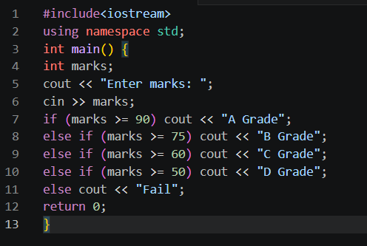
*Output
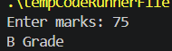
*Explanation of Logic
The if-else-if ladder tests conditions sequentially. The moment one condition is true, its block runs and all
remaining conditions are skipped. This guarantees exactly one outcome and is more efficient than multiple
separate if statements.
Question 44: What is the difference between if and switch?
*Problem Statement
Compare the if-else and switch conditional structures across multiple criteria.
*Algorithm / Steps
if-else:- Tests any condition (ranges, complex expressions)- Works with any data type- Flexible but verbose for many choices
switch:- Tests ONE variable against CONSTANT values- Only int, char, enum allowed- Cleaner and faster for fixed constant checks
*Dry Run
if can do: if (x > 0 && x < 100) [range check]
switch cannot do ranges directly.
switch can do: case 1: case 2: case 3 [constants]
*C++ Code
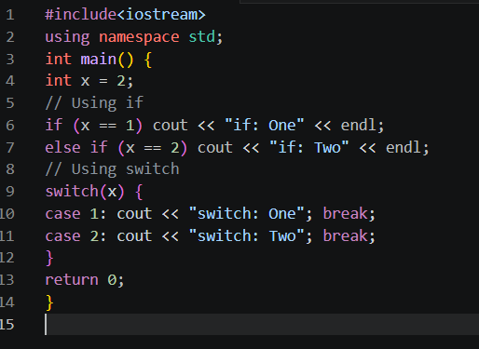
*Output
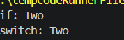
*Explanation of Logic
Use switch for clean menu/constant selection; use if-else for complex conditions involving ranges, strings,
or logical operators. Both achieve the same result but switch is more readable for fixed discrete values.
Question 45: Can switch use ranges directly?
*Problem Statement
Determine whether a C++ switch statement can directly handle ranges of values like if-else can.
*Algorithm / Steps
1. Standard C++ switch CANNOT handle ranges.
2. case accepts only single constant values.
3. Workaround: use if-else for ranges.
4. Some compilers support range extensions but they are non-standard.
*Dry Run
// INVALID:
switch(marks) {
case 90-100: ... // ERROR: not valid syntax
}
// VALID workaround: use if-else
if (marks >= 90 && marks <= 100) ...
*C++ Code
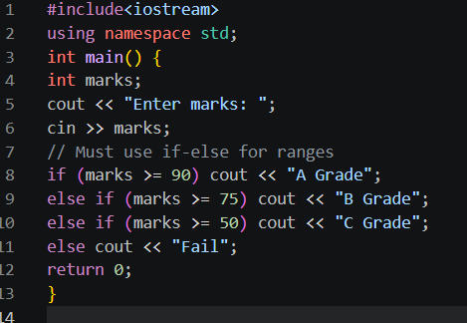
*Output
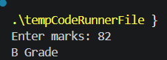
*Explanation of Logic
switch only accepts exact constant values per case — no ranges. For range-based decisions, if-else is the
correct tool. This is one of switch's key limitations and a common reason to prefer if-else for grade
calculations.

Question 46: What is fall-through in switch?
*Problem Statement
Explain the fall-through behavior in switch statements and when it is useful or harmful.
*Algorithm / Steps
1. Fall-through: when break is absent, execution continues
into the NEXT case after the matched one.
2. Can be intentional (multiple cases, same action).
3. Usually unintentional -> bug.
*Dry Run
x=1, no breaks:
case 1 -> runs "One"
case 2 -> runs "Two" [fell through]
case 3 -> runs "Three" [fell through]

Intentional use:
case 1:
case 2: cout << "1 or 2"; break; // both go here
*C++ Code
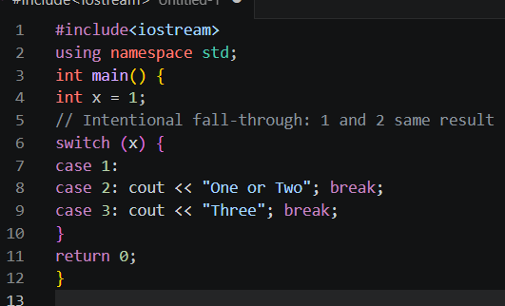
*Output
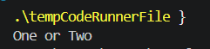
*Explanation of Logic
Fall-through lets multiple cases share the same code block without repeating it. In the example, both case
1 and case 2 lead to the same output. While useful deliberately, accidental fall-through (forgetting break) is
a common bug.
Question 47: What data type is usually used for conditions?
*Problem Statement
Identify the data type used as the result of conditional expressions in C++.
*Algorithm / Steps
1. Conditions evaluate to bool (Boolean) type.
2. bool holds only: true (1) or false (0).
3. Relational and logical expressions return bool.
4. Non-zero values are treated as true; zero as false.
*Dry Run
int x = 5;
bool result = (x > 3);-> 5 > 3 -> true -> result = 1
bool flag = (x == 10);-> 5 == 10 -> false -> flag = 0
*C++ Code
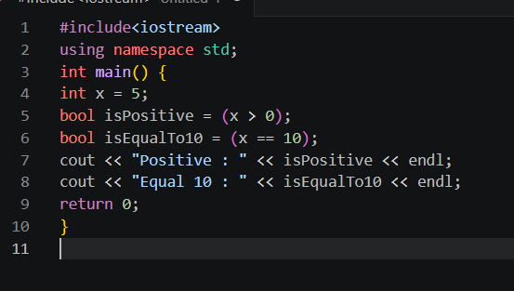
*Output
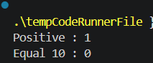
*Explanation of Logic
The bool data type stores the result of conditions. In C++, any non-zero value is treated as true and 0 as
false. This allows integers to be used as conditions directly, e.g., if(x) is valid when x is an int.

Question 48: Why are conditional statements important?
*Problem Statement
Explain the significance and practical importance of conditional statements in programming.
*Algorithm / Steps
Conditional statements are important because they:
1. Enable programs to make decisions dynamically.
2. Allow different outputs for different inputs.
3. Handle errors and edge cases.
4. Make programs interactive and intelligent.
5. Are the foundation of algorithms and logic.
*Dry Run
Without conditionals: same output always.
With conditionals:
Marks=90 -> "Grade A"
Marks=60 -> "Grade C"
Marks=30 -> "Fail"
Program adapts to data.
*C++ Code
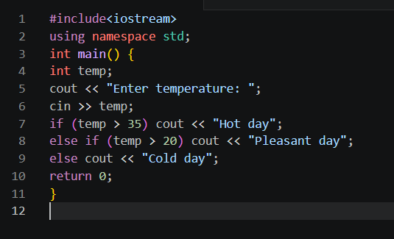
*Output
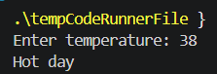
*Explanation of Logic
Without conditional statements, programs would execute the same sequence of steps every time, making
them useless for real-world problems that require different responses to different situations. Conditionals
are the decision-making engine of every program.

Question 49: Give one real-life example of a conditional statement.
*Problem Statement
Provide a real-world scenario that maps directly to an if-else conditional structure in C++.
*Algorithm / Steps
Real-life scenario: ATM PIN check
If PIN entered == correct PIN:
Allow access to account
Else:
Show 'Incorrect PIN' message
*Dry Run
entered = 1234, correct = 1234
entered == correct -> TRUE -> "Access Granted"

entered = 9999, correct = 1234
entered == correct -> FALSE -> "Incorrect PIN"
*C++ Code
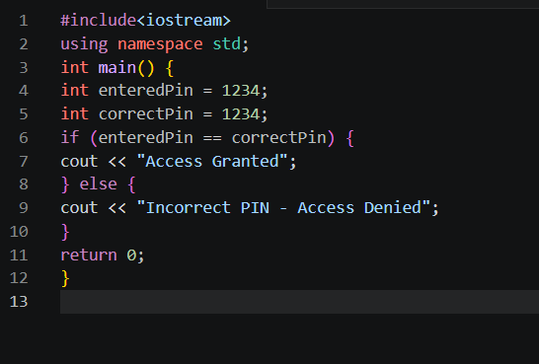
*Output
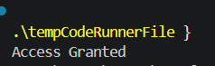
*Explanation of Logic
The ATM PIN check is a perfect real-life analogy. The condition (entered PIN == stored PIN) maps exactly
to an if-else. This shows how everyday decision-making directly translates into conditional statements in
code.

Question 50: Name four conditional structures covered.
*Problem Statement
List and briefly describe the four main conditional structures used in C/C++ programming.
*Algorithm / Steps
Four conditional structures:
1. if - single condition check
2. if-else - two-way decision
3. if-else-if - multi-way decision (ladder)
4. switch-case - discrete constant value selection
*Dry Run
if: if (x > 0) ...
if-else: if (x > 0) ... else ...
if-else-if: if (x>90) ... else if (x>75) ... else ...
switch: switch(x) { case 1: ... case 2: ... }
*C++ Code
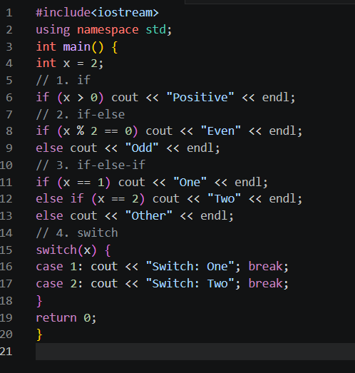
*Output
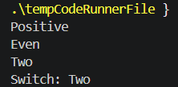
*Explanation of Logic
These four structures cover all decision-making needs: if for simple checks, if-else for binary choices,
if-else-if ladder for multiple ranges or options, and switch for clean discrete value matching. Mastering all
four is essential for writing effective C++ programs.

